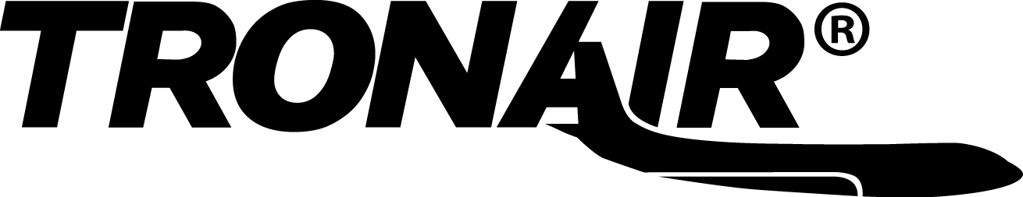

Operation & Service Manual

Model: 02-7844-0111

30 Ton Single Stage Jack

08/2001 – Rev. 02

Includes Illustrated Parts Lists

When ordering Replacement Parts/Kits, please specify Model and Serial Number of your Unit.

TABLE OF CONTENTS

PAGE

1.0 DESCRIPTION 1
2.0 USAGE 1
3.0 SPECIFICATIONS 1
4.0 ASSEMBLY INSTRUCTIONS 1
4.1 GENERAL INSTRUCTION 1
4.2 PRE-USE CHECKS 1
5.0 OPERATING INSTRUCTIONS 1
5.1 JACK INSTRUCTIONS 1
6.0 MAINTENANCE 2
6.1 GENERAL 2
6.2 REMOVING AND SERVICING PUMP 2
6.3 JACK FUNCTION LOAD TEST 2
7.0 TROUBLE SHOOTING 3
8.0 GUARANTEES/LIMITATION OF LIABILITY 3

APPENDIX I HC-1822
APPENDIX II INS-1495 K-1001 Pump Seal Kit Instruction
APPENDIX III MSDS Hydraulic Fluid – MIL-PRF-5606

This product can not be modified without the written approval of Tronair, Inc. Any modifications done without written approval voids all warranties and releases Tronair, Inc., it suppliers, distributors, employees, or financial institutions from any liability from consequences that may occur. Only Tronair OEM replacement parts shall be used.

1.0 DESCRIPTION
The Tronair Single Stage jack incorporates the following quality features:
- Steel Construction
- Mechanical ram lock nut that prevents lowering of jack under load
- Quick action mechanical extension
- Single speed, manually operated pump with pressure relief
- Uses standard MIL-PRF-5606 hydraulic fluid

2.0 USAGE
The purpose of the following jack is to lift the aircraft for maintenance. See 3.0 Specifications for capacity of the jack.

3.0 SPECIFICATIONS
- Rated Capacity: 60,000 lbs
- Minimum Closed Height: 46 inches
- Mechanical Extension: 16 inches
- Hydraulic Extension: 27 inches
- Maximum Height Obtainable: 89 inches
- Weight: 500 lbs
- Pressure Relief Setting: 4000+250/-100 psig
- BUNA ‘N’ Seals

4.0 ASSEMBLY INSTRUCTIONS

4.1 GENERAL INSTRUCTION
This product should be assembled and/or repaired using good workmanship practices and proper tools. Bolts and elastic stopnuts should be tightened to a torque not to exceed industry standards for Grade '5' bolts. The -24 bolts should be tightened to 35 ft-lbs.

All replacement parts must be the same as or equal to the original parts supplied.

4.2 PRE-USE CHECKS
Refer to the Jack Illustrated Parts List on Pages 4 through Error: Reference source not found to identify and ensure that all parts are present.
- Generally check over unit to assure the tightness of all nuts, bolts and fittings.
- With rams completely collapsed, check hydraulic fluid level; three-quarter inch (3/4") below vent.
Replenish with MIL-PRF-5606 fluid as required.

5.0 OPERATING INSTRUCTIONS
The user should be familiar with the following statements prior to using the jack(s):


CAUTION!
1. Never put hands between the aircraft and the jack pad; as after aircraft has been lowered, struts may have hung up.
2. Never align jack under aircraft by pounding on jack legs. Dented legs may lead to jack collapse.
3. Always lower ram locking nut(s) after jack is under load. Be sure ram nut(s) is seated fully after jacking.
4. Always raise and lower jacks simultaneously so that aircraft remains level.
5. Always use a tail or nose stand, as applicable, for additional stability.

5.1 JACK INSTRUCTIONS
To Raise Aircraft:
- Place jack on a hard, level surface.
- Raise mechanical extension as close to aircraft jack pad as possible.
- Close pump release valve and operate pump.
- Lower ram locknuts as aircraft is raised.

5.1 JACK INSTRUCTIONS (continued)
To Lower Aircraft:
- Lower all jacks simultaneously.
- If ram locking nut(s) is tight, raise jack slightly to release nut(s).
- Loosen pump release valve slightly to slowly lower aircraft. Raise locking nut(s) as jack ram(s) lower.
NOTE: When using the jack during a washing or cleaning operation, the jack should be completely covered to protect it from cleaning solution, dirt and/or foreign material which might get on or between the ram and cylinder causing damage to the seals and O-rings.

6.0 MAINTENANCE

6.1 GENERAL
- All maintenance and/or repair work should be done using good workmanship practices and proper tools.
- The work area should be clean and free of dirt.
- When O-rings and backup rings are removed, every effort should be made to avoid the contact of tools with the critical surfaces of parts. Surface deformities could cause degradation of seals and failure.
- It is good practice to replace both O-rings and backup rings once removed. Cut and damaged O-rings normally result in fluid leakage.
- If cylinder bore is found to be rusty, it may be honed to a maximum diameter of 4.506 inches and a surface finish of 16 micro inches. If pitting in the bore cannot be removed by this process, the jack cylinder must be replaced before the jack can be returned to service.
- At this time, flush old hydraulic fluid and dirt from overall system and replenish with new, clean hydraulic fluid.

90-Day Routine Maintenance
If jack is not being used on a regular basis, every 90 days the jack should be fully extended and retracted to exercise the seals and to prevent rust build up on the cylinder inside diameter. While ram is extended, clean the threads and spray with DoALL RPM, LPS, or equivalent that is water repellent and will not harm BUNA "N" O-rings.

To Disassemble Jack:
- Remove mounting plate (Item 31) by unscrewing five (5) socket head cap screws (Item 30).
- Raise ram assembly (Item 33) to the point where it can be lifted from the jack cylinder.

To Re-assemble Jack:
- Re-assemble in reverse order of above.
- Spray inside diameter of cylinder and outside diameter of ram (Items 1 & 33) with DoALL RPM, LPS or equivalent water repellent that will not harm the BUNA "N" O-rings to protect surfaces from rusting when not in use.
NOTE: To minimize air entrapment under the ram, raise the oil level in the cylinder to chamfer of the cylinder prior to ram insertion.

6.2 REMOVING AND SERVICING PUMP
NOTE: If pump is found faulty, call the factory for replacement or replace seals as follows:
- Reference Appendix I, HC-1822 during the following:
- Clamp suction (push-on) hose and remove hose from pump.
- Uncouple fitting of hydraulic hose from pump.
- Remove pump from jack.
- Remove cotter pin from clevis pin.
- Remove four (4) socket head cap screws.
- Remove flanges.
- Remove tube assembly.
- Replace O-rings and backup ring. (See Appendix I, HC-1822 for kits available).
- Re-assemble in reverse order.

6.3 JACK FUNCTION LOAD TEST
NOTE: If function load testing is required:
- Take all necessary precautions to prevent injury.
- Always jack against a load and never against the jack itself.
- Do not exceed a test load equal to the jack rated capacity plus 10%.

7.0 TROUBLE SHOOTING
TROUBLE | PROBABLE CAUSE | ACTION
Fluid leakage at pump piston or pump body | Damaged backup ring, o-ring, piston or pump body | Remove piston and pump body. Inspect for damage. Replace defective part(s). Replace removed o-ring and backup ring
External fluid leakage at rams | Damaged o-ring, backup ring or inner cylinder wall | Remove rams as a unit from cylinder. Inspect parts. Replace o-ring and defective part(s)
Jack fails to lift rated load | Release valve not closed properly | Fully tighten release valve
Jack fails to lift rated load | Low fluid level | Fill to correct fluid level
Jack fails to lift rated load | Pressure relief valve improperly adjusted | Adjust or replace release valve
Jack fails to lift rated load | Leakage at inlet or outlet check ball | Inspect valve body for wear or replace valve body and check balls
Jack fails to lift rated load | Vent screw closed | Open vent screw
Rams will not support load after manual or pneumatic pump up | Leaking ram o-ring seals | Check for external leakage, if present replace defective seal and back up ring
Rams will not support load after manual or pneumatic pump up | Leaking pressure check valve | Inspect valve body for wear or replace valve body and check balls
Rams will not support load after manual or pneumatic pump up | Leaking pressure relief valve | Remove release valve, inspect ball and ball seat in pump block. Replace effective part(s)
Rams raise and fall with each manual pump stroke | Release valve open | Fully tighten release valve
Rams raise and fall with each manual pump stroke | Inlet check valve not seated or sticking | Pump rapidly to dislodge or replace valve body
Rams raise and fall with each manual pump stroke | Pressure check valve not seated or sticking | Pump rapidly to dislodge or replace valve body
Jack fails to lower | Ram locknut not loosened | Raise jack ¼ inch and release locknut
Jack fails to lower | Vent screw closed | Open vent screw
Jack fails to lower | O-Ring (pinched or rolled) | Replace o-ring and back-up ring, clean up cylinder wall of debris

8.0 GUARANTEES/LIMITATION OF LIABILITY
Tronair products are warranted to be free of manufacturing or material defects for a period of one year after shipment to the original customer. This is solely limited to the repair or replacement of defective components. This warranty does not cover the following items:
- Parts required for normal maintenance
- Parts covered by a component manufacturers warranty
- Replacement parts have a 90-day warranty from date of shipment
If you have a problem that may require service, contact Tronair immediately. Do not attempt to repair or disassemble a product without first contacting Tronair, any action may affect warranty coverage. When you contact Tronair be prepared to provide the following information:
- Product Model Number
- Product Serial Number
- Description of the problem
If warranty coverage is approved, either replacement parts will be sent or the product will have to be returned to Tronair for repairs. If the product is to be returned, a Return Material Authorization (RMA) number will be issued for reference purposes on any shipping documents. Failure to obtain a RMA in advance of returning an item will result in a service fee. A decision on the extent of warranty coverage on returned products is reserved pending inspection at Tronair. Any shipments to Tronair must be shipped freight prepaid. Freight costs on shipments to customers will be paid by Tronair on any warranty claims only. Any unauthorized modification of the Tronair products or use of the Tronair products in violation of cautions and warnings in any manual (including updates) or safety bulletins published or delivered by Tronair will immediately void any warranty, express or implied.

The obligations of Tronair expressly stated herein are in lieu of all other warranties or conditions expressed or implied. Any unauthorized modification of the Tronair products or use of the Tronair products in violations of cautions and warnings in any manual (including updates) or safety bulletins published or delivered by Tronair will immediately void any warranty, express or implied and Tronair disclaims any and all liability for injury (without limitatioN and including DEATH), loss or damage arising from or relating to such misuse.

Parts List
When ordering Replacement Parts/Kits, please specify Model, Color and Serial Number of your Unit.
Item | Part Number | Description | Qty
2 | H-1009-01 | Handle, Hydraulic Pump | 1
 | K-3329 | Kit, Jack Weldment Replacement; consists of:
1 | Z-4971-01 | Weldment, Jack, (with Labels) | 1
 | K-2920 | Kit, Caster Replacement; consists of:
3 | G-1203-1105 | Jamnut, 5/8-18 Elastic | 3
4 | TR-1347 | Spacer, Axle | 3
5 | G-1250-1100N | Flatwasher, 5/8 Narrow | 3
6 | H-2210-07 | Spring, Compression | 3
7 | R-1839 | Bushing, Caster Guide | 3
8 | G-1250-1110W | Flatwasher, 3/4 Wide | 3
9 | U-1053 | Caster, Swivel | 3

Parts List
When ordering Replacement Parts/Kits, please specify Model, Color and Serial Number of your Unit.
Item | Part Number | Description | Qty
11 | TF-1043-06*22.5 | Assembly, Hose | 1
16 | N-2016-05-S | Tee, Swivel Nut Run | 1
17 | N-2004-15-S | Elbow, Extra Long, 90° Male | 1
18 | N2250-10 | Adapter, Expanding Pipe | 1
 | K-3385 | Kit, Pump Replacement; consists of:
10 | N-2410-05 | Elbow, 90° Male | 1
12 | N-2001-08-S-B | Elbow, 90° Male | 1
13 | HC-1822 | Hand Pump, Hydraulic | 1
14 | G-1251-1070R | Lockwasher, 3/8 Regular | 2
15 | G-1100-107010 | Bolt, Hex Head, Grade 5, 3/8-16 x 1" long | 2
Not Shown | TF-1047-04*06.5 | Hose, Push-on | 1

Parts List
When ordering Replacement Parts/Kits, please specify Model, Color and Serial Number of your Unit.
Item | Part Number | Description | Qty
 | K-3386 | Kit, Reservoir Replacement; consists of:
19 | N-2412-09 | Connector, Barbed Hose | 1
20 | N-2208-01-S | Tee, Male Branch | 1
21 | TF-1047-04*06.5 | Hose, Push-on | 1
22 | N-2205-03-S | Plug, Hollow Hex | 1
23 | H-1045 | Breather | 1
24 | G-1250-1050N | Flatwasher, 1/4 Narrow | 5
25 | G-1100-105006 | Bolt, Hex Head, Grade 5, 1/4-20 x 3/4" long | 1
26 | HJ-580-01-01 | Assembly, Reservoir (with Labels) | 1
27 | G-1202-1050 | Stopnut, 1/4-20 Elastic | 4

Parts List
When ordering Replacement Parts/Kits, please specify Model, Color and Serial Number of your Unit.

Item | Part Number | Description | Qty
28 | R-1150 | Screw, Extension | 1
29 | H-2326 | Nut, Ram | 1
30 | G-1151-109210 | Screw, Socket Head Cap, 1/2-13 x 1" long | 5
31 | TR-1740 | Plate, Mounting | 1
33 | Z-1611 | Assembly, Ram | 1
34 | HJ-557 | Pad, Jack | 1
35 | G-1300-31200 | Roll Pin, 5/16" diameter x 2" long | 1
36 | H-2329 | Nut, Extension | 1
 | K-1051 | Kit, Seal Ram Replacement; consists of:
32 | HJ-706 | Ring, Guide | 1
37 | HC-2020-346 | Ring, Backup | 1
38 | HC-2000-346 | O-ring | 1
NOTES: 1) Those items designated as kits contain all hardware necessary for installation.
2) Unless otherwise listed, all replacement bolts are to be Grade '5' or better.

APPENDIX I

HC-1822

4000 psi

Hand Pump

Parts List

Model: HC-1822
4000 psi
Hand Pump

***

Parts List
With
Illustrations

08/2001 – Rev. OR

When ordering Replacement Parts/Kits, please specify Model, Color and Serial Number of your Unit.

Parts List
This pump is compatible with MIL-PRF-5606/MIL-PRF-83282 Hydraulic Fluids only.
Reference Illustration on following page.
Item | Part Number | Description |  | Qty
3 | Not Sold Separately | Pump Body | Reference
12 | 506-000 | Flange Half |  | 4
25 | 518-000 | Screw, Socket Head Cap |  | 4
Not Shown | H-1009-01 | Handle |  | 1
 | K-1001 | Seal, Replacement Kit; consists of:
4 |  | O-ring, Release Screw |  | 1
6 |  | O-ring, Outlet Check |  | 1
11 |  | O-ring, Valve Body |  | 1
21 |  | Wiper, Rod |  | 1
22 |  | Ring, Backup |  | 1
23 |  | O-ring, Piston |  | 1
27 |  | O-ring, Tube Seal |  | 1
♦ Not Shown |  | O-ring, Inlet Check |  | 1
♦ Not Shown |  | O-ring, Guide Shoe |  | 2
♦ Not Shown |  | Piston, Guide Shoe |  | 1
 | K-1068 | Linkage, Replacement Kit; consists of:
13 |  | Pivot |  | 1
14 |  | Assembly, Linkage Pin |  | 2
17 |  | Strap |  | 2
18 |  | Assembly, Clevis Pin |  | 1
19 |  | Bracket, Pump Handle |  | 1
 | K-1069 | Internal Parts, Replacement Kit; consists of:
7 |  | Spring, Inlet Check |  | 1
8 |  | Spring, Outlet Check |  | 1
9 |  | Ball, Outlet Check |  | 1
10 |  | Ball, Inlet Check |  | 1
♦ Not Shown |  | Ball, Release |  | 1
 | K-1778 | Piston/Cylinder, Replacement Kit; consists of:
15 |  | Piston |  | 1
16 |  | Tube |  | 1
20 |  | Retainer, Wiper |  | 1
24 |  | Assembly, Valve Body (Includes Items 7, 10, 24, 26) |  | 1
 | K-1906 | Piston/Seal, Replacement Kit; consists of:
15 |  | Piston |  | 1
22 |  | Ring, Backup |  | 1
23 |  | O-ring, Piston |  | 1
 | K-2988 | Release Screw, Replacement Kit; consists of:
2 |  | Screw, Release |  | 1
30 |  | Retainer, Screw |  | 1
All other parts available in Replacement Kits only.
♦ Although this item is listed in a particular kit, it is not used on HC-1822-01 pump. Item may be discarded.

Parts List Illustration
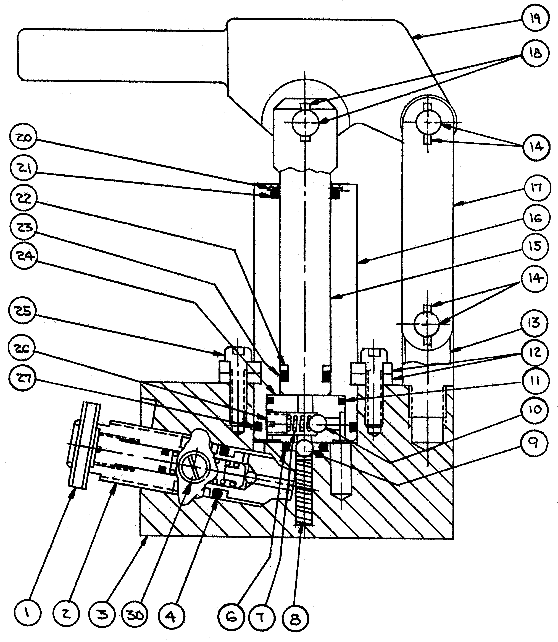
WARNING!
Item 2 is a preset relief valve. Do not disassemble this valve.
replacement parts are available as a preset relief valve assembly

APPENDIX II

INS-1495

K-1001

Pump Seal Kit

Instruction

 | INSTRUCTION  Page 1 of 3 | DOCUMENT NUMBER:  INS-1495
Product: K-1001 Pump Seal Kit |  | DATE: 03/02/98 | REV: OR

Note: Your kit contains replacement parts for the pump shown below as well as parts for older versions of this pump.
If your pump differs from the Illustration below, refer to Page 3 for correct assembly of internal parts.

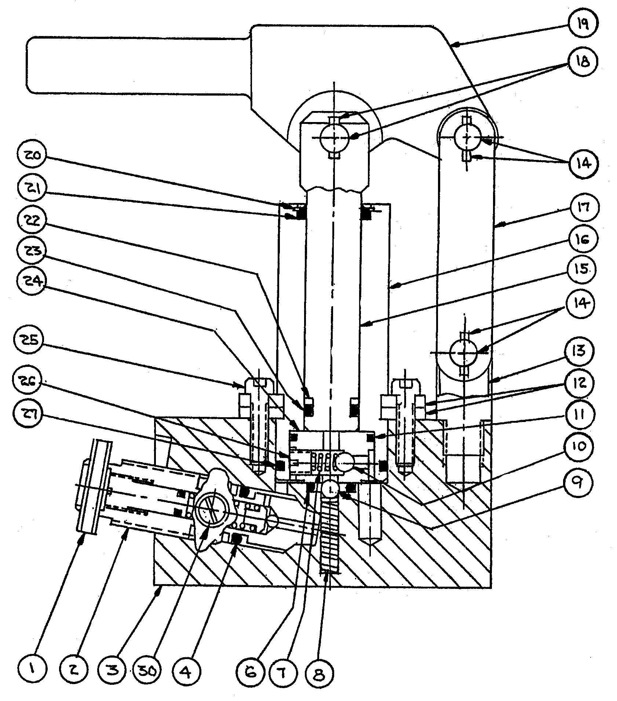

WARNING!
Item 2 is a preset relief valve. Do Not disassemble this valve.
Replacement parts are available as a preset relief valve assembly

INSTRUCTIONS:
1. Inspect all parts. Replace all worn or otherwise defective parts.
2. Clean all parts prior to re-assembly.
3. Lubricate all O-rings with clean system hydraulic fluid prior to installation.
4. Torque pump screws (Item 25) to 10 ft-lbs.

Parts List

Item | Part Number | Description | Qty
1 |  | Available only with Item 2
2 |  | Release Screw/Relief Valve Assembly | -
3 |  | Pump Body | -
♦ 4 | 526-060 | Release Screw O-ring | 1
5 |  | Release Ball (Shown on Page 3) | -
♦ 6 | 522-000 | Outlet Check O-ring | 1
7 |  | Inlet Check Spring | -
8 |  | Outlet Check Spring | -
9 |  | Outlet Check Ball | -
10 |  | Inlet Check Ball | -
♦ 11 | 524-000 | Valve Body O-ring | 1
12 |  | Flange Half | -
13 |  | Pivot | -
14 |  | Linkage Pin Assembly | -
15 |  | Piston | -
16 |  | Tube | -
17 |  | Strap | -
18 |  | Clevis Pin Assembly | -
19 |  | Pump Handle Bracket | -
20 |  | Wiper Retainer | -
♦ 21 | 528-060 | Rod Wiper | 1
♦ 22 | 534-060 | Backup Ring | 1
♦ 23 | 526-060 | Piston O-ring | 1
24 |  | Valve Body Assembly | -
25 |  | Socket Head Cap Screw | -
26 |  | Pipe Plug | -
♦ 27 | 525-002 | Tube Seal O-ring | 1
28 |  | Handle (Not Shown) | -
29 |  | Deleted | -
30 |  | Release Screw Retainer | -
♦ 31 | 523-000 | Inlet Check O-ring (Shown on Page 3) | 1
♦ 32 | 522-000 | Guide Shoe O-ring (Shown on Page 3) | 2
♦ 33 | 527-060 | Piston Guide Shoe (Shown on Page 3) | 1
♦ Items are included in this kit.

Parts reference of older pump designs:
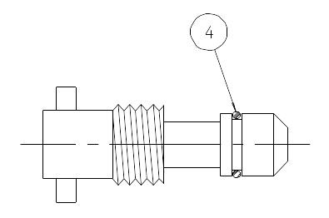
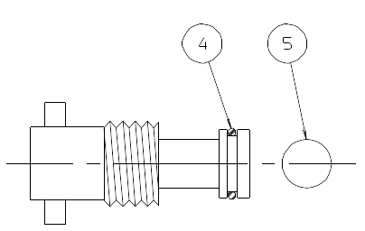
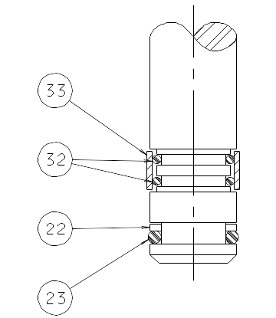

Seal Installation for Older Piston Design
Seal Installation for Older Valve Body Design

Seal Installation for Older Release Screw Designs

APPENDIX III

MSDS

Hydraulic Fluid

(MIL-PRF-5606)

